Kingdom of Saudi Arabia  Ministry of Education  Hafr Al Baten Educational Directorate for boys  Al –Ajial International Schools |  |  |  | 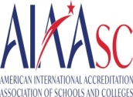    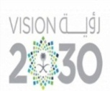 |  |  | Subject: Computer  Class.: Grade 3  Time:……….
……………… |  | Seat Number |  | ………………………………………… |  |  |  | Student’s Name
MID-SEMESTER EXAM
FIRST SEMESTER 2024/2025 SESSION
Sign. | Consultative Name |  | Sign. |  | Corrector’s Name | Marks in letters |  |  | Marks  in numbers
 |  |  |  |  |  |  |  |  | 20
INSTRUCTION: ANSWER ALL QUESTIONS

Question A: Match the following with the correct software icons.

-  | Sketchbook
-  | Paint
-  | Calendar
-  | Gallery
-  | Notebook

Question A: Match the following according to their usage.

 | FOR BANKING
 | FOR ENTERTAIMENT
 | FOR EDUCATION
 | FOR ART
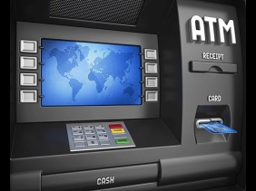 | FOR COMMUNICATION

GOOD LUCK

